Tema 2

Pescaru Mihai

**Business events:**

- Auth form sent (User)

- Reputation point given (User)

- Topic posted (User)

- Topic updated (User)

- Topic searching (User)

- Reply posted (User)

- Reply updated (User)

**Contexts:**

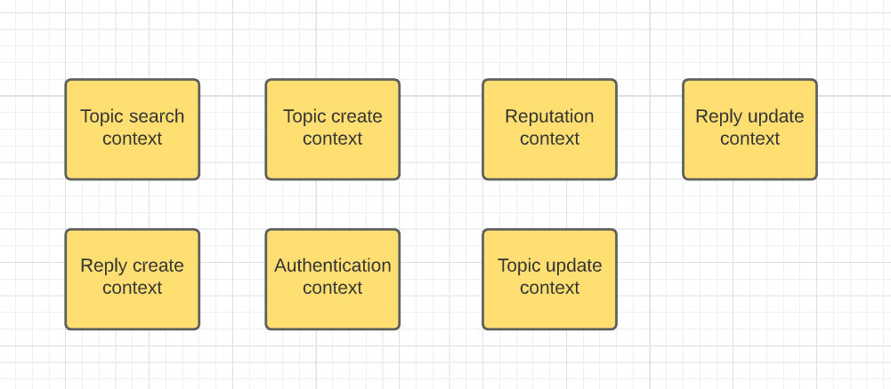

**Context map:**

